Dear Artist,
Thank you for your interest in the CONtraflow X Art Show and Auction. CONtraflow is a three-day, fanrun, general science fiction convention with a literary focus held annually in the New Orleans metro area. Our show is dedicated to all genres of science fiction, fantasy, comics, gaming, and anime/manga.
The CONtraflow Art Show features three-dimensional and two-dimensional art in a variety of media within the themes of science fiction, fantasy, comics, gaming, or anime/manga. Our show consists of artwork for viewing or purchase throughout the weekend and an auction on Sunday afternoon. We also provide space for a “Print Shop” to allow for sales of unframed or duplicates of hanging artwork.
You will find the rules for the Show / Auction / Print Shop below as well as a registration form, bidding sheets, and control sheets. Please fill out these sheets as completely as possible so that we may keep track of your work and sales. We must receive confirmation of your participation by September 15, 2022 to reserve your spot. Artwork, registration form, and payment must be received by September 29, 2022.
You may also deliver your work to the convention site in person on Friday, October 7, 2022 between 9:00 am and 11:00 am provided you have already registered for the show. Space is limited and is available on a first come, first served basis.
Please contact us if you have any questions and thank you for choosing to display/sell your work with CONtraflow.

Julie Schiavo
Art Show & Sale, CONtraflow X

CONtraflow Art Show/Auction/Print Shop Submission Guidelines
CONtraflow is a Science/Science Fiction/Fantasy oriented convention, so please keep this in mind when sending your work. If you think it fits our theme, send it in! We welcome both 2D and 3D art.
There is a $0.50 per piece hanging fee for art entered in the art show. There is no charge to hang artist name cards. Be prepared to share panels/tables with other artists. All art should be prepared for display.
There will be a print shop for prints and reproductions submitted by artists. There is no hanging fee for print shop items, only for art displayed in the art show. Print shop items are sold through direct sale, not through bid.
Currently, there is no limit to art entered in the art show. Hanging space will be available on a first-come, first-serve basis. Walk-in artists are accepted and encouraged but please reserve your space. Table space for three-dimensional pieces is available on request.
We will can hang one copy of a limited edition print in the art show promoting further copies displayed in the print shop. This must be clearly described on the art show and print shop control sheets. An original may also by hung in the art show marked “Not for Sale” and prints included in the print shop.
CONtraflow receives a 12% commission on all art sold through the art show, auction, and print shop. Checks will be mailed to the artists (or their agents if so requested) within three weeks of the convention end date.
Mail-in art should be sent to: CONtraflow Art Show c/o Julie Schiavo
868 Germain Street
New Orleans, LA 70124

All packages must be clearly marked as artwork for the CONtraflow Art Show. Mail-in art must be shipped in sturdy, reusable shipping containers. Art not sold at the convention may be picked up on Sunday of the convention for attending artists/guests after 2 pm. Mail-in art will be sent back within three weeks after CONtraflow. (If possible, United Parcel Service (UPS) will be used to return art - it is automatically insured for $100 and the package is traceable.) If payment for hanging fees, postage, and any shipping insurance the artist may request is not provided by the artist and is not covered by sales, CONtraflow will retain the art and contact the artist to make arrangements.
Permission to use copyrighted characters, when required, is the responsibility of the artist, not of CONtraflow. We will cooperate with legitimate efforts to enforce copyrights.
CONtraflow staff will provide security while the art show is open. The room will be locked when the show is closed. If you have questions not answered by the information above, please contact us.
CONtraflow does offer the option for artists to participate in an after auction minimum bid sale. Just let us know if you wish to offer your work in such a sale by checking the appropriate line in Artists Control Sheet. Thank you for reading the Artist Guidelines. We hope you have a good convention and sell everything you submit!
I have read and agree with the guidelines above: ___________________________

CONtraflow Art Show Control Sheet
Artist Name: ________________________________________________ Phone: __________________________
Address: ___________________________________________ Website: _____________________________________ City: ____________________________ State: _____ ZIP: ________ Email: _________________________________ May we give out your address/email/website to ____Other art shows ____Anyone who asks ___Do not release my info

Make check payable to: _________________________________________________________________
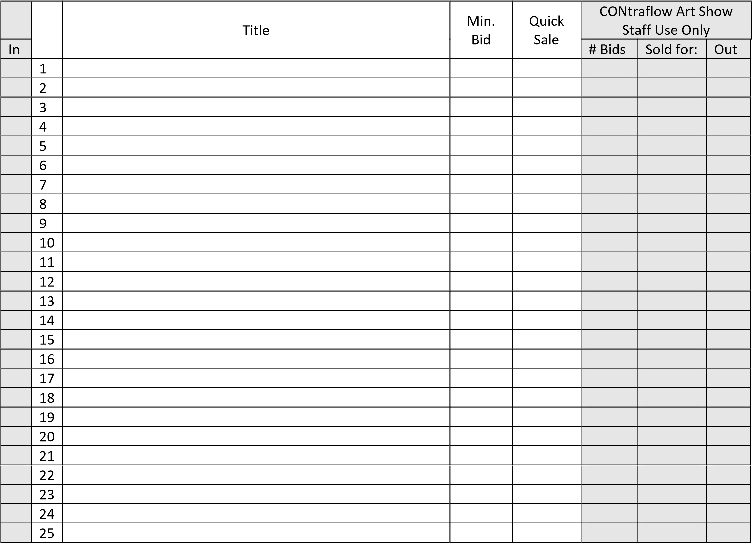

Hanging fees: $ ____________ Pre-paid return shipping: $ __________ Insure return shipping for $ _______________
I have read and accept the CONtraflow Art Show guidelines: ___________________________________________ I do______ do not____ wish to submit works for an after-auction minimum bid sale.

CONtraflow Print Shop Control Sheet
Artist Name: ________________________________________________ Phone: __________________________
Address: ___________________________________________ Website: _____________________________________ City: ____________________________ State: _____ ZIP: ________ Email: _________________________________ May we give out your address/email/website to ____Other art shows ____Anyone who asks ___Do not release my info

Make check payable to: _________________________________________________________________
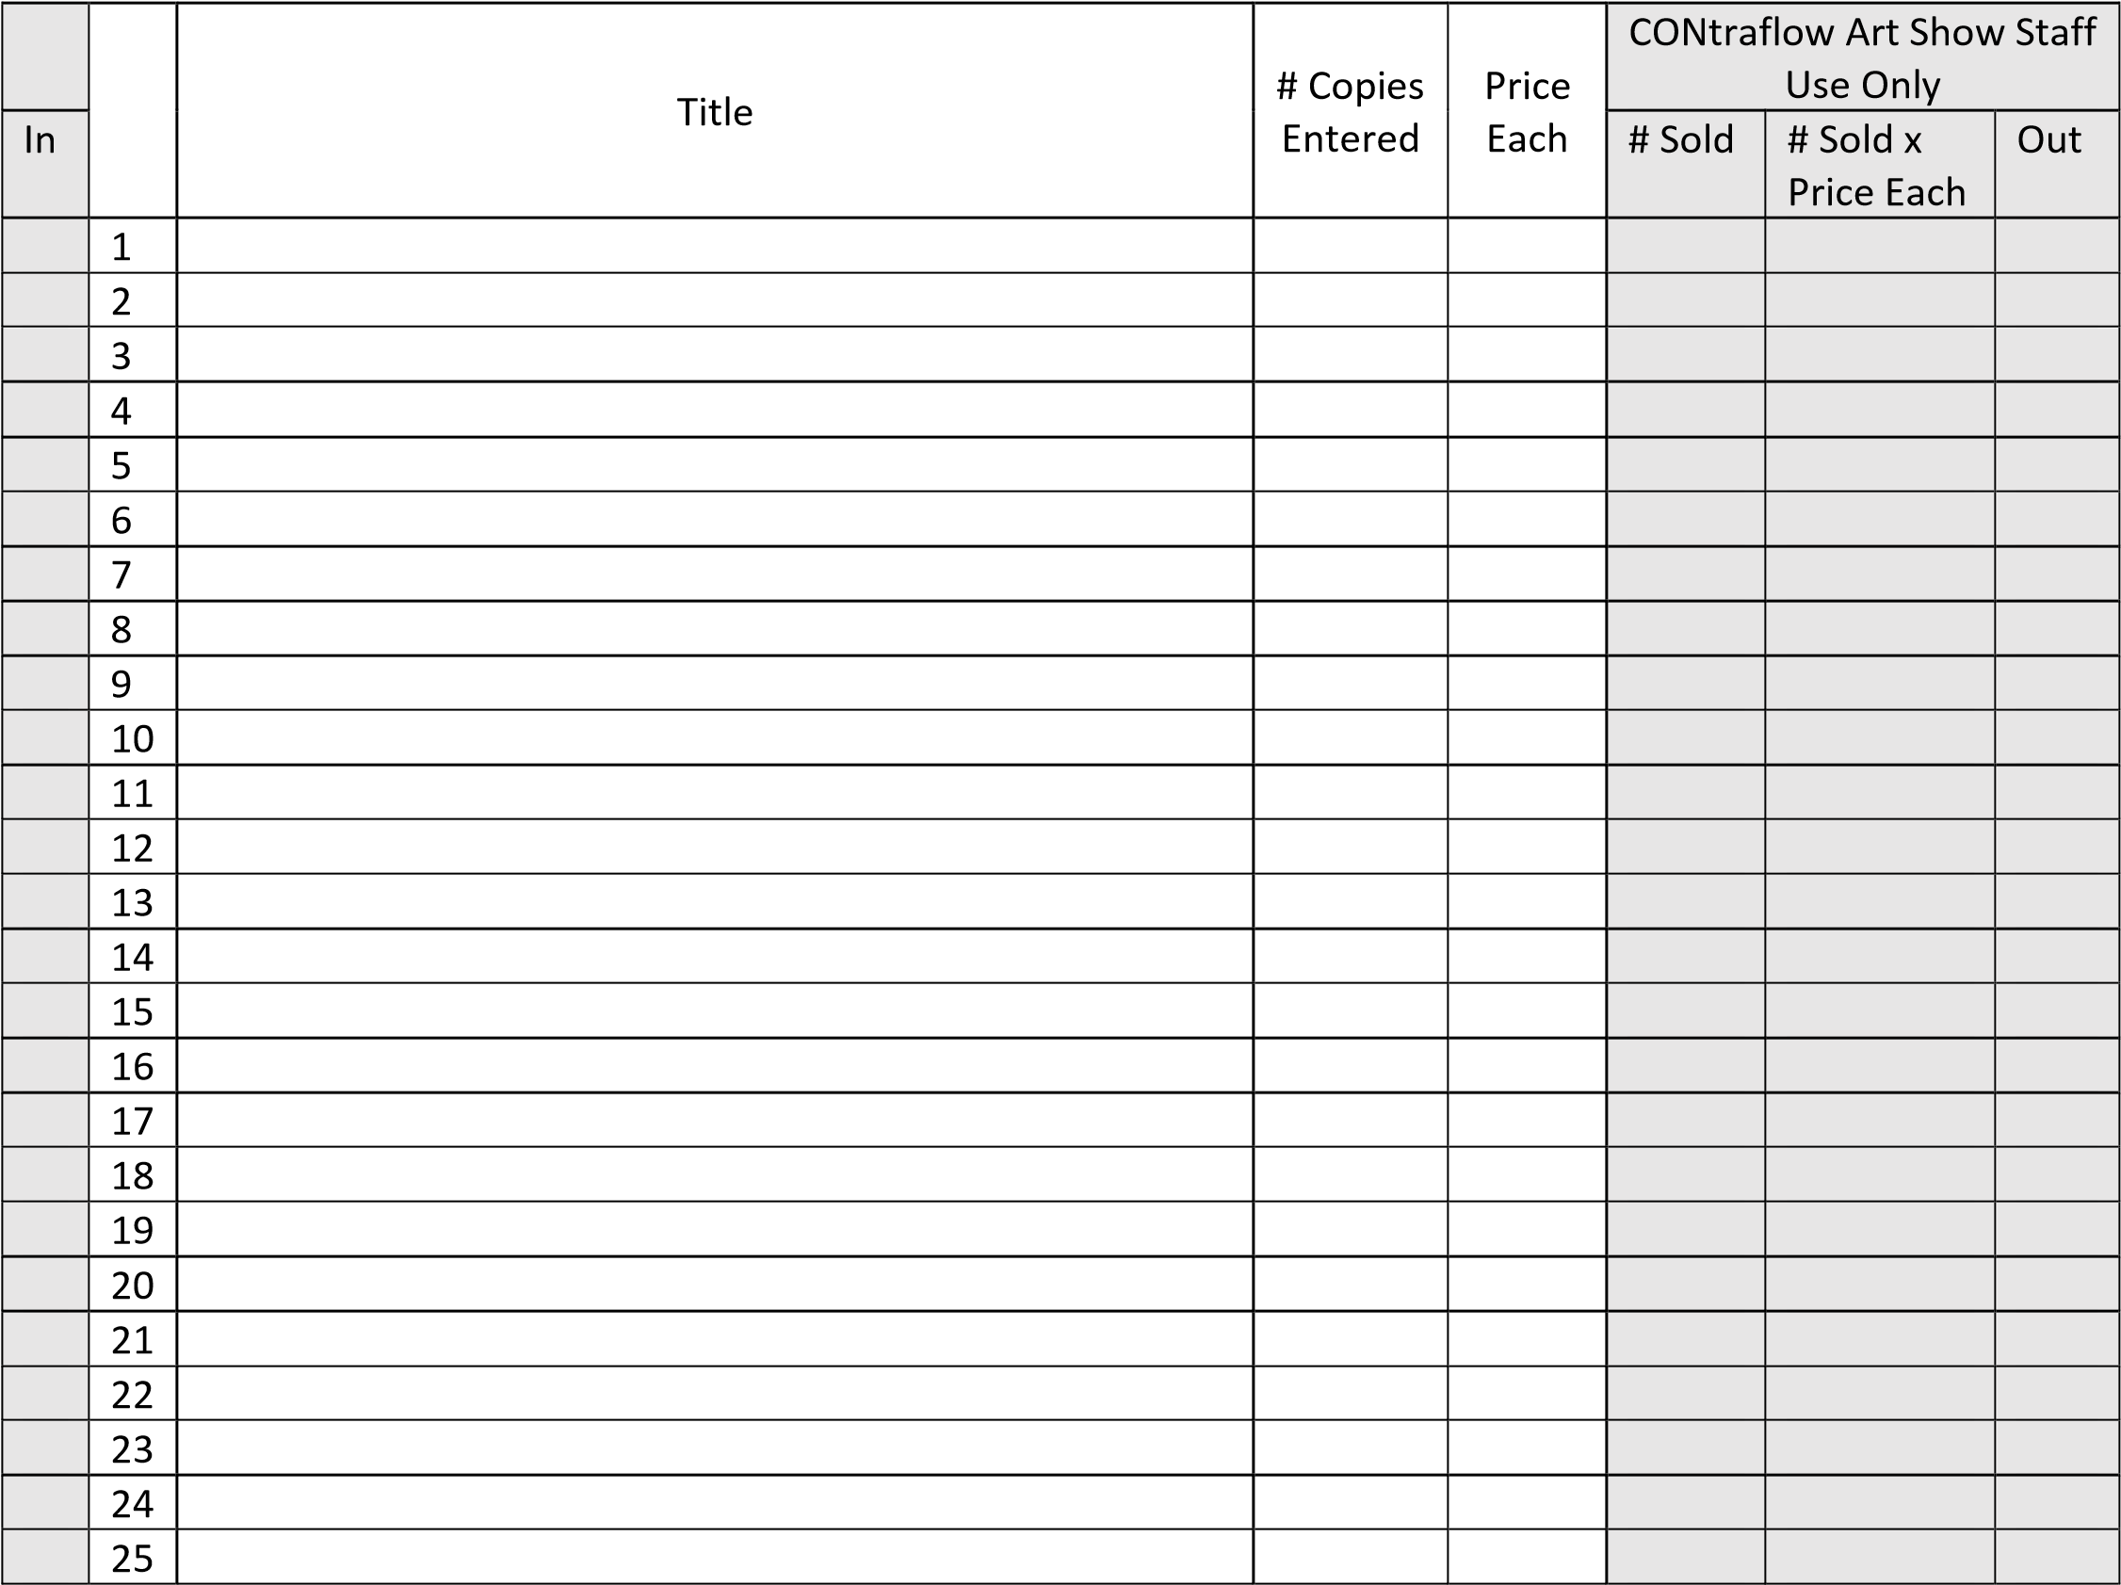

Pre-paid return shipping: $ __________ Insure return shipping for $ ______________ I have read and accept the CONtraflow Art Show guidelines: _______________________________________________________

Artist Title | CONtraflow  Art Show Bid Sheet
 | Item # (from Control Sheet):
Minimum Bid |  | $
Quick Sale $
Bidder Badge Number Bid Amount
Buyer Amount Paid

Artist Title | CONtraflow  Art Show Bid Sheet
 | Item # (from Control Sheet):
Minimum Bid |  | $
Quick Sale $
Bidder Badge Number Bid Amount
Buyer Amount Paid

Artist Title | CONtraflow  Art Show Bid Sheet
 | Item # (from Control Sheet):
Minimum Bid |  | $
Quick Sale $
Bidder Badge Number Bid Amount
Buyer Amount Paid

Artist Title | CONtraflow  Art Show Bid Sheet
 | Item # (from Control Sheet):
Minimum Bid |  | $
Quick Sale $
Bidder Badge Number Bid Amount
Buyer Amount Paid

